Diagrams

# Authored by Delvin Varghese and Dominic Lee

**Sequence Diagrams**

The sequence diagrams are shown below

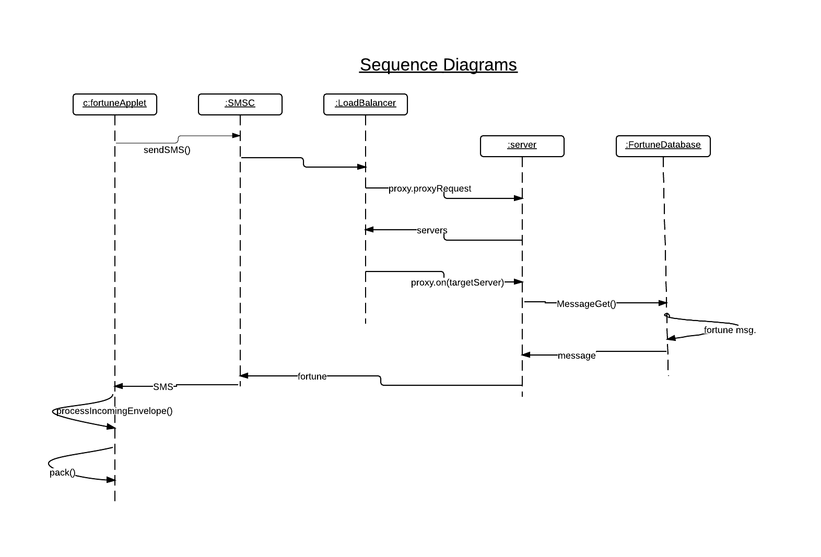

**Class Diagrams**

The class diagrams are shown below:

